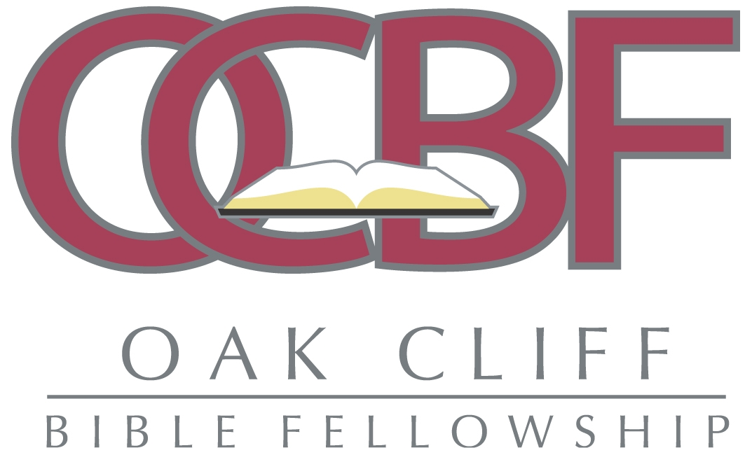
News Release
1808 W. Camp Wisdom Road • Dallas, TX 75232 • 214.672.9100 • www.ocbfchurch.org

FOR INFORMATION CONTACT: FOR IMMEDIATE RELEASE
Shari Carroll 214.672.9100, ext. 1006

Beth Moore and Tara Jenkins Speak at Women’s Conference

Oak Cliff Bible Fellowship, Dr. Lois Evans presents women’s conference

DALLAS, July 14, 2010 – About 3,000 women are expected to attend the 2010 Desperate for Jesus Women’s Conference, Friday and Saturday, July 23 and 24 at Oak Cliff Bible Fellowship, where Dr. Tony Evans is senior pastor.

“Many women carry tremendous burdens at home, in their careers, or in their personal lives. Sometimes these burdens can evoke feelings of frustration or discouragement. This year’s conference will revive and inspire all in attendance by reminding women that although we may feel bruised, we are not broken. God’s sufficiency will meet us right where we are giving us all that we need because, in Him, we are fearfully and wonderfully made.” Dr. Lois Evans said.

Women will be empowered through dynamic messages by national Christian speakers such as—Beth Moore, author of the bestseller, Breaking Free; Tara Jenkins, bestselling author of Wisdom for Wives: 21 Things Every Pastor’s Spouse Should Know; and Dr. Tony Evans, national speaker and author of over 50 books, including A Whole New You, The Kingdom Agenda, and Marriage Matters.

Priscilla Shirer, teacher and author of Going Beyond Ministries, is conference host.

Conference workshops will waste no time in getting to the heart and soul of the matter by presenting topics such as “Don’t Be a Desperate Wife”; Living Life With a Purpose; and Let Me Upgrade You. These workshops will motivate women to make life-changing decisions that bring about brighter tomorrows.

The conference is $45 with lunch included. Women can pre-register online through July 22 at www.ocbfchurch.org. For more information about the conference, call Oak Cliff Bible Fellowship at 214.672-9100, ext. 1006.

NOTE: To schedule an interview with a conference speaker(s), please contact Shari Carroll at Oak Cliff Bible Fellowship, 214-672-9100, ext. 1006 or scarroll@ocbfchurch.org.

-30-

